让我们一同守护您的健康

中华医院减免医药费申请表

Application Form for Medical Fee Waiver

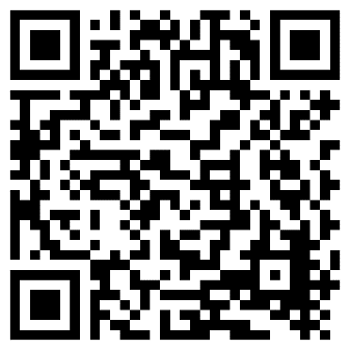

Let us protect your health together

福利卡/援助卡类別（请参考）

Types of Medical Benefit Card / Health Assist Card (Please refer to).

1.社区保健计划藍色援助卡 (CHAS Blue Health Assist Card);

2.公共援助卡 (Public Assistance Card);

3.社区医疗福利卡

(Community Medical Benefit Card, CMB Elderly & CMB Disabled);

4.关怀过渡计划卡 (ComCare Transitions (CCT));

5.医疗費豁免卡 (Medical Fee Exemption Card);

6.其他，请注明 Others, Please state.

申请者条件Criteria of Applicant

医药津贴/Medical Subsidy

请扫描QR码获取《减免医药费申请表》

或向医院办公室咨询

Please scan QR code to obtain the

“Application Form for Medical Fee Waiver”

or make an enquiry at our branches' office.

家庭人均收入低于$1500/月

Family income per capita is less than $1500/month

医药费半费

50% Waiver

医药费全免

Full waiver

家庭人均收入低于$750/月

Family income per capita is less than $750/month

\*The final approval rights belong to SCHMI

\*最终决定权归中华医院所有