

**李月香**

驻院医师

新加坡注册中医师

**学历背景：**  
新加坡中医学院/中国广州中医药大学  中医学学士学位

**科别：**  
中医内科、针灸、中医妇科

**中医临床经验：**  
5年以上

|  |  |
| --- | --- |
| **看诊时间** | |
|  | **武吉班让分院** |
| **星期一** | 9am-5pm |
| **星期二** | 9am-5pm |
| **星期三** | 9am-5pm |
| **星期四** | 1:30pm-10pm |
| **星期五** | 9am-5pm |
| **星期六** | 9am-12:30pm |



**Lee Nyiat Siang**

Resident Physician

TCMPB Registered Physician

**Educational Background:**Bachelor of Medicine (Chinese Medicine), Singapore College of Traditional Chinese Medicine/Guangzhou University of Chinese Medicine (China)

**Division:**  
TCM Internal Medicine, Acupuncture & Moxibustion, TCM Gynecology (Women’s Health)

**TCM Clinical Experience:**  
More than 5 years

|  |  |
| --- | --- |
| **Consultation Hours** | |
|  | **Bukit Panjang** |
| **Mon** | 9am-5pm |
| **Tue** | 9am-5pm |
| **Wed** | 9am-5pm |
| **Thu** | 1:30pm-10pm |
| **Fri** | 9am-5pm |
| **Sat** | 9am-12:30pm |

TCMPB Registered Physician

Educational Background:

Bachelor of Medicine (Chinese Medicine), Singapore College of Traditional Chinese

Division:

TCM Internal Medicine, Acupuncture & Moxibustion, TCM Gynecology (Women’s Health)

TCM Clinical Experience:

More than 5 years

Table 的打法 ：

<table style="width: 39.478%;" border="1">

<tbody>

<tr style="height: 29px;">

<td style="width: 203.494%; text-align: center; height: 29px;" colspan="2"><span style="color: #333333;"> Consultation Hours</span></td>

</tr>

<tr style="height: 29px;">

<td style="width: 29.1139%; text-align: center; height: 29px;"><strong> Mon</strong></td>

<td style="width: 174.38%; text-align: center; height: 29px;"><span style="color: #ff0000;">9am-5pm</span></td>

</tr>

<tr style="height: 29px;">

<td style="width: 29.1139%; text-align: center; height: 29px;"><strong> Tue</strong></td>

<td style="width: 174.38%; text-align: center; height: 29px;"><span style="color: #ff0000;">9am-5pm</span></td>

</tr>

<tr style="height: 10px;">

<td style="width: 29.1139%; text-align: center; height: 10px;"><strong>Wed</strong></td>

<td style="width: 174.38%; text-align: center; height: 10px;"><span style="color: #ff0000;">9am-5pm</span></td>

</tr>

<tr style="height: 29px;">

<td style="width: 29.1139%; text-align: center; height: 29px;"><strong>Thurs</strong></td>

<td style="width: 174.38%; text-align: center; height: 29px;"><span style="color: #ff0000;">1:30pm-10pm</span></td>

</tr>

<tr style="height: 10px;">

<td style="width: 29.1139%; text-align: center; height: 10px;"><strong> Fri</strong></td>

<td style="width: 174.38%; text-align: center; height: 10px;"><span style="color: #ff0000;">9am-5pm</span></td>

</tr>

<tr style="height: 29px;">

<td style="width: 29.1139%; text-align: center; height: 29px;"><strong>Sat</strong></td>

<td style="width: 174.38%; text-align: center; height: 29px;"><span style="color: #ff0000;">9am-12:30pm</span></td>

</tr>

</tbody>

</table>

*Description的打法是去copy 别的医师的description然后paste在所要做的医师里再修改update的信息。因为它是用command的形式。*

新加坡注册中医师

<span style="text-decoration: underline">学历背景</span>：

新加坡中医学院/中国广州中医药大学 中医学学士学位

<span style="text-decoration: underline">科别</span>：

中医内科、针灸、中医妇科

<span style="text-decoration: underline">中医临床经验</span>：

5年以上

<table style="border-collapse: collapse;width: 17.0413%;height: 192px">

<tbody>

<tr style="height: 24px">

<td style="width: 18.9107%;height: 24px;text-align: center" colspan="2"><strong>看诊时间</strong></td>

</tr>

<tr style="height: 24px">

<td style="width: 6.68992%;height: 24px"></td>

<td style="width: 12.2208%;height: 24px"><strong>武吉班让分院</strong></td>

</tr>

<tr style="height: 24px">

<td style="width: 6.68992%;height: 24px"><strong>星期一</strong></td>

<td style="width: 12.2208%;height: 24px"><span style="color: #ff0000">9am-5pm</span></td>

</tr>

<tr style="height: 24px">

<td style="width: 6.68992%;height: 24px"><strong>星期二</strong></td>

<td style="width: 12.2208%;height: 24px"><span style="color: #ff0000">9am-5pm</span></td>

</tr>

<tr style="height: 24px">

<td style="width: 6.68992%;height: 24px"><strong>星期三</strong></td>

<td style="width: 12.2208%;height: 24px"><span style="color: #ff0000">9am-5pm</span></td>

</tr>

<tr style="height: 24px">

<td style="width: 6.68992%;height: 24px"><strong>星期四</strong></td>

<td style="width: 12.2208%;height: 24px"><span style="color: #ff0000">1:30pm-10pm</span></td>

</tr>

<tr style="height: 24px">

<td style="width: 6.68992%;height: 24px"><strong>星期五</strong></td>

<td style="width: 12.2208%;height: 24px"><span style="color: #ff0000">9am-5pm</span></td>

</tr>

<tr style="height: 24px">

<td style="width: 6.68992%;height: 24px"><strong>星期六</strong></td>

<td style="width: 12.2208%;height: 24px"><span style="color: #ff0000">9am-12:30pm</span></td>

</tr>

</tbody>

</table>

&nbsp;

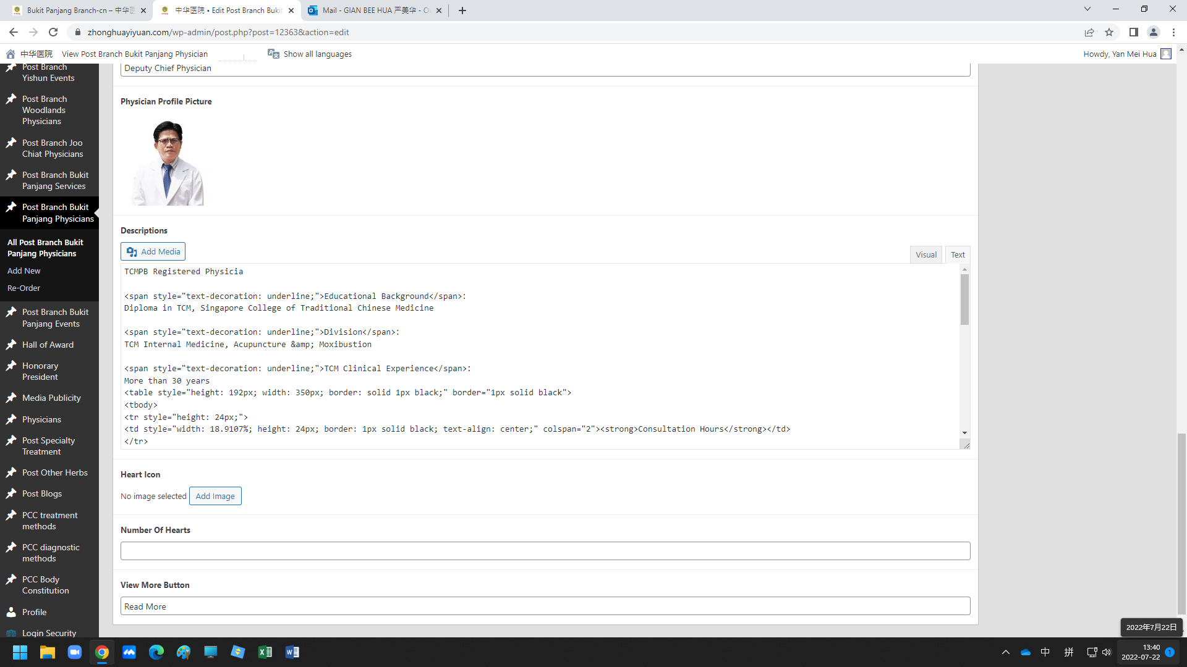

Heart Icon 可以去Google 找，找时打Heart Icon， 然后把心的图片save 起来。在Add Image把它insert进去。或search时打入**Vector-Smart-Object-2.png**

在View More Buttong 打入 Read More 或查看更多

*在Google 找Heart Icon*

<https://www.google.com/search?q=heart+icon&rlz=1C1GCEU_enSG997SG997&oq=&aqs=chrome.0.69i59i450l3.2783451873j0j7&sourceid=chrome&ie=UTF-8>

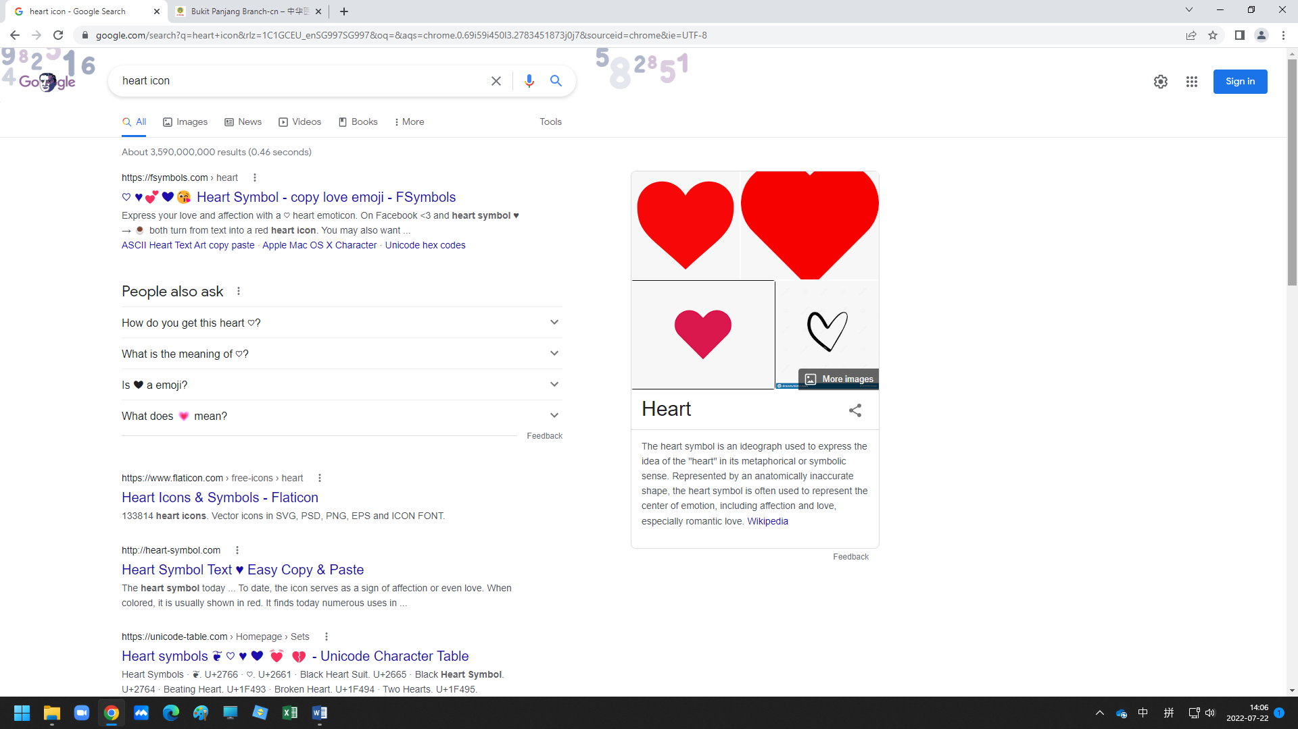

张惠强-Englist

<table style="height: 192px; width: 350px; border: solid 1px black;" border="1px solid black">

<tbody>

<tr style="height: 24px;">

<td style="width: 18.9107%; height: 24px; border: 1px solid black; text-align: center;" colspan="2"><strong>Consultation Hours</strong></td>

</tr>

<tr style="height: 24px;">

<td style="width: 6.68992%; height: 24px; border: 1px solid black; text-align: center;"><strong>Mon</strong></td>

<td style="width: 12.2208%; height: 24px; border: 1px solid black; text-align: center;"><span style="color: #000000;">6:30pm-10pm</span></td>

</tr>

<tr style="height: 24px;">

<td style="width: 6.68992%; height: 24px; border: 1px solid black; text-align: center;"><strong>Tue</strong></td>

<td style="width: 12.2208%; height: 24px; border: 1px solid black; text-align: center;"><span style="color: #000000;">6:30pm-10pm</span></td>

</tr>

<tr style="height: 24px;">

<td style="width: 6.68992%; height: 24px; border: 1px solid black; text-align: center;"><strong>Wed</strong></td>

<td style="width: 12.2208%; height: 24px; border: 1px solid black; text-align: center;"><span style="color: #000000;">6:30pm-10pm</span></td>

</tr>

<tr style="height: 24px;">

<td style="width: 6.68992%; height: 24px; border: 1px solid black; text-align: center;"><strong>Thu</strong></td>

<td style="width: 12.2208%; height: 24px; border: 1px solid black; text-align: center;"><span style="color: #000000;">6:30pm-10pm</span></td>

</tr>

<tr style="height: 24px;">

<td style="width: 6.68992%; height: 24px; border: 1px solid black; text-align: center;"><strong>Fri</strong></td>

<td style="width: 12.2208%; height: 24px; border: 1px solid black; text-align: center;"><span style="color: #000000;">6:30pm-10pm</span></td>

</tr>

<tr style="height: 24px;">

<td style="width: 6.68992%; height: 24px; border: 1px solid black; text-align: center;"><strong>Sat</strong></td>

<td style="width: 12.2208%; height: 24px; border: 1px solid black; text-align: center;"><span style="color: #000000;">6:30pm-10pm</span></td>

</tr>

</tbody>

</table>

&nbsp;

翁亚庆-English

<span style="text-decoration: underline;">TCM Clinical Experience</span>：

More than 30 years

<table style="height: 192px; width: 350px; border: solid 1px black;" border="1px solid black">

<tbody>

<tr style="height: 24px;">

<td style="width: 18.9107%; height: 24px; border: 1px solid black; text-align: center;" colspan="2"><strong>Consultation Hours</strong></td>

</tr>

<tr style="height: 24px;">

<td style="width: 6.68992%; height: 24px; border: 1px solid black; text-align: center;"></td>

<td style="width: 12.2208%; height: 24px; border: 1px solid black; text-align: center;"><strong>武吉班让分院</strong></td>

</tr>

<tr style="height: 24px;">

<td style="width: 6.68992%; height: 24px; border: 1px solid black; text-align: center;"><strong>Mon</strong></td>

<td style="width: 12.2208%; height: 24px; border: 1px solid black; text-align: center;"><span style="color: #000000;">9am-5pm</span></td>

</tr>

<tr style="height: 24px;">

<td style="width: 6.68992%; height: 24px; border: 1px solid black; text-align: center;"><strong>Tue</strong></td>

<td style="width: 12.2208%; height: 24px; border: 1px solid black; text-align: center;"><span style="color: #000000;">9am-5pm</span></td>

</tr>

<tr style="height: 24px;">

<td style="width: 6.68992%; height: 24px; border: 1px solid black; text-align: center;"><strong>Wed</strong></td>

<td style="width: 12.2208%; height: 24px; border: 1px solid black; text-align: center;"><span style="color: #000000;">9am-5pm</span></td>

</tr>

<tr style="height: 24px;">

<td style="width: 6.68992%; height: 24px; border: 1px solid black; text-align: center;"><strong>Thu</strong></td>

<td style="width: 12.2208%; height: 24px; border: 1px solid black; text-align: center;"><span style="color: #000000;">9am-12:30pm</span></td>

</tr>

<tr style="height: 24px;">

<td style="width: 6.68992%; height: 24px; border: 1px solid black; text-align: center;"><strong>Fri</strong></td>

<td style="width: 12.2208%; height: 24px; border: 1px solid black; text-align: center;"><span style="color: #000000;">9am-5pm</span></td>

</tr>

<tr style="height: 24px;">

<td style="width: 6.68992%; height: 24px; border: 1px solid black; text-align: center;"><strong>Sat</strong></td>

<td style="width: 12.2208%; height: 24px; border: 1px solid black; text-align: center;"><span style="color: #000000;">9am-5pm</span></td>

</tr>

</tbody>

</table>

&nbsp;

陳有珊-English

&nbsp;

<table style="width: 350px;" border="1">

<tbody>

<tr>

<td style="text-align: center;" colspan="6"> <strong>Consultation Hours</strong></td>

</tr>

<tr>

<td style="text-align: center;"><strong> BUKIT PANJANG BRANCH</strong></td>

<td style="text-align: center;"><strong>FRI</strong></td>

<td style="text-align: center;"> 1:30pm-5pm</td>

</tr>

</tbody>

</table>